UNIT – I INTRODUCTION AND APPLICATION LAYER
Building network – Network Edge and Core – Layered Architecture – OSI Model – Internet Architecture (TCP/IP) Networking Devices: Hubs, Bridges, Switches, Routers, and Gateways – Performance Metrics – Introduction to Sockets –
Application Layer protocols – HTTP – FTP Email Protocols – DNS.

  - Building network
A computer network or data network is a telecommunications network which allows computers to exchange data. In computer networks, networked computing devices pass data to each other along network links (data connections). Data is transferred in the form of packets. The connections between nodes are established using either cable media or wireless media. The best- known computer network is the Internet.
To build a computer network is defining what a network is and understanding how it is used to help a business meet its objectives. A network is a connected collection of devices and end systems, such as computers and servers, which can communicate with each other.
These are the four major categories of physical components in a computer network:

- Personal computers (PCs): The PCs serve as endpoints in the network, sending and receiving data.
- Interconnections: The interconnections consist of components that provide a means for data to travel from one point to another point in the network. This category includes components such as the following:
  - Network interface cards (NICs) that translate the data produced by the computer into a format that can be transmitted over the local network
  - Network media, such as cables or wireless media, that provide the means by which the signals are transmitted from one networked device to another
  - Connectors that provide the connection points for the media
- Switches: Switches are devices that provide network attachment to the end systems and intelligent switching of the data within the local network.
- Routers: Routers interconnect networks and choose the best paths between networks.
Network User Applications:
The key to utilizing multiple resources on a data network is having applications that are aware of these communication mechanisms. Although many applications are available for users in a network environment, some applications are common to nearly all users.
The most common network user applications include the following:
- E-mail: E-mail is a valuable application for most network users. Users can communicate information (messages and files) electronically in a timely manner, to not only other users in the same network but also other users outside the network (suppliers, information resources, and customers, for example). Examples of e-mail programs include Microsoft Outlook and Eudora by Qualcomm.
- Web browser: A web browser enables access to the Internet through a common interface. The Internet provides a wealth of information and has become vital to the productivity of both home and business users. Communicating with suppliers and customers, handling orders and fulfillment, and locating information are now routinely done electronically over the Internet, which saves time and increases overall productivity. The most commonly used browsers are Microsoft Internet Explorer, Netscape Navigator, Mozilla, and Firefox.
- Instant messaging: Instant messaging started in the personal user-to-user space; however, it soon provided considerable benefit in the corporate world. Now many instant messaging applications, such as those provided by AOL and Yahoo!, provide data encryption and logging, features essential for corporate use.
- Collaboration: Working together as individuals or groups is greatly facilitated when the collaborators are on a network. Individuals creating separate parts of an annual report or a business plan, for example, can either transmit their data files to a central resource for compilation or use a workgroup software application to create and modify the entire document, without any exchange of paper. One of the best-known traditional collaboration software programs is Lotus Notes. A more modern web-based collaboration application is a wiki.
- Database: This type of application enables users on a network to store information in central locations (such as storage devices) so that others on the network can easily retrieve selected information in the formats that are most useful to them. Some of the most common databases used in enterprises today are Oracle and Microsoft SQL Server

    - Network Edge and Core
In the architecture of computer networks, the network edge refers to the outermost layer where end systems—commonly referred to as hosts—are located. These hosts include a wide range of devices such as personal computers, laptops, smartphones, tablets, and increasingly, embedded systems like smart appliances and IoT (Internet of Things) devices.
The primary function of the network edge is to serve as the starting point or the destination for communication over the internet. These edge devices are responsible for executing application programs, including web browsers, email clients, and streaming services. They typically operate under one of two architectural models: the client-server model, where a client (like a browser) initiates communication and a server responds, and the peer-to-peer model, where both ends act as clients and servers interchangeably, facilitating services like file sharing without centralized infrastructure.
    - Access Networks
An access network is essentially the intermediate network that bridges the communication between an end system and the nearest edge router of the Internet Service Provider (ISP). This is the first hop a data packet takes when it begins its journey across the internet. Depending on the environment, access networks vary significantly. In residential settings, common access technologies include DSL (Digital Subscriber Line), which uses telephone lines; cable networks that use coaxial cables; and increasingly, fiber-optic lines which offer much higher bandwidth. In enterprise or institutional environments, Ethernet LANs (Local Area Networks) are widely used, typically offering high-speed and reliable connections. On the wireless side, access networks include Wi-Fi for local connectivity and 4G/5G cellular networks for mobile connectivity, enabling access even in motion or remote areas.
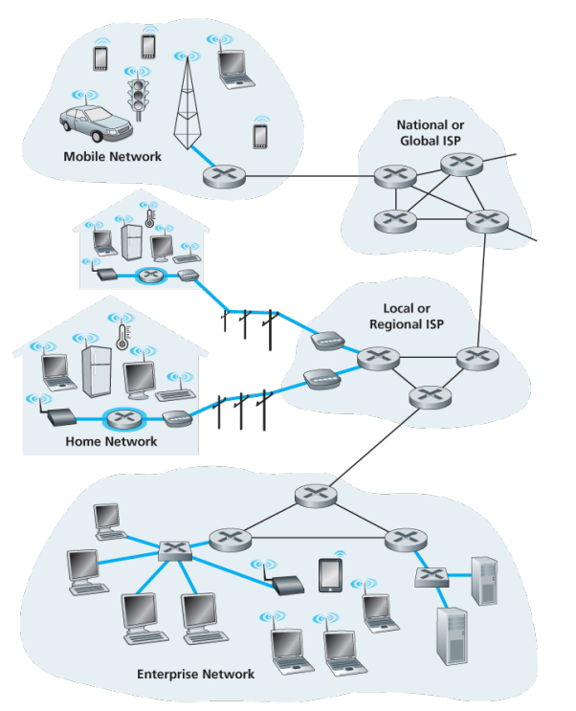
Fig 1.1.Access Networks
1.1.2.1 DSL Internet Access
Broadband residential access is primarily provided through DSL (Digital Subscriber Line) and cable Internet access. DSL uses the existing telephone line to transmit data without interrupting regular telephone service by utilizing separate frequency bands: 0–4 kHz for voice, 4–50 kHz for upstream data, and 50 kHz–1 MHz for downstream data. A DSL modem at the user end connects to a DSLAM at the telephone company’s central office. DSL is often asymmetric, offering different upload and download speeds, and performance depends heavily on the distance between the home and the CO(Central office-typically effective within 5–10 miles). In contrast, cable Internet leverages the cable TV infrastructure. Fiber optics carry data to neighborhood fiber nodes, which then use coaxial cables to reach homes.
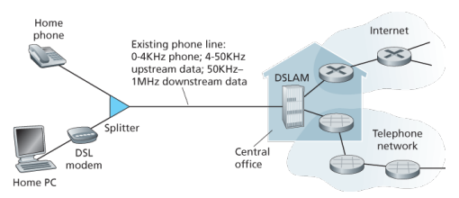
Fig1.2 DSL Internet Access
1.1.2.2 Cable Internet Access
This hybrid fiber-coax (HFC) system connects hundreds to thousands of homes. At the provider’s end, a CMTS (Cable Modem Termination System) plays a similar role to DSLAM, converting signals for the network. Cable access is also asymmetric and shared among users, leading to variable speeds based on local demand. Standards like DOCSIS 2.0 define the performance limits for cable modems. However, the shared nature of cable networks can lead to reduced performance during high usage. An emerging, faster alternative is Fiber to the Home (FTTH), where fiber-optic cables run directly from the CO to individual homes, bypassing bandwidth-sharing issues and supporting much higher speeds.

1.1.2.3 Shared Medium & FTTH (Fiber to the Home)
One important limitation of cable Internet access is that it operates as a shared medium. Every packet sent from the provider’s head end is broadcast to all homes in the neighborhood, and packets from users travel upstream on a shared channel. As a result, if multiple users are simultaneously streaming or downloading large files, the available bandwidth is divided among them, which can reduce individual performance. This shared nature also affects the upstream channel, requiring coordination to avoid collisions. To address these issues, a newer technology called Fiber to the Home (FTTH) is gaining popularity. FTTH uses a dedicated optical fiber line from the central office directly to each home, ensuring consistent and high-speed internet access without shared congestion. Many countries, including South Korea, Japan, and Sweden, have widely adopted FTTH, achieving household penetration rates above 30%. FTTH represents the next generation of broadband, delivering superior reliability and performance compared to traditional DSL and cable systems.
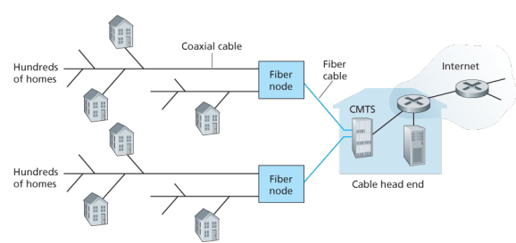
Fig 1.4 A Hybrid Fiber coaxial access network
1.1.2.4 FTTH Internet Access
Fiber to the Home (FTTH) delivers high-speed internet using optical fibers. A central office sends data through an optical splitter to optical network terminals (ONTs) at homes. Users connect a home router to the ONT for internet access. This Passive Optical Network (PON) setup allows data replication at the splitter and supports gigabit-level speeds. FTTH is significantly faster than older technologies like DSL or cable, though speed and pricing vary by provider. In rural areas, satellite internet or even dial-up connections may still be used, though these are much slower.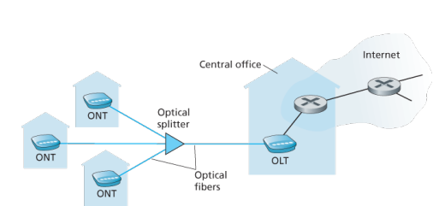
Fig1.5 FTTH Internet Access
1.1.2.5 Ethernet Internet Access
Ethernet access is commonly used in enterprise or institutional environments. Devices like computers and servers connect to an Ethernet switch via wired connections (typically 100 Mbps or 1 Gbps, with servers supporting up to 10 Gbps). The switch is connected to an institutional router, which links to the Internet through an ISP. Although traditionally wired, modern networks often include WiFi for wireless access using IEEE 802.11 standards. WiFi enables connectivity in places like universities and airports, but requires proximity to an access point and typically supports speeds over 100 Mbps.

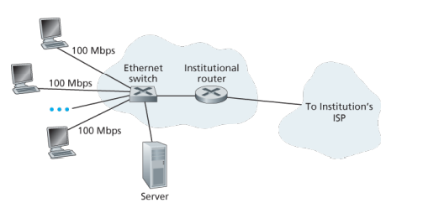
Fig 1.6 Ethernet Internet Access
1.1.2.6 Typical Home Network & 3G/LTE Access
Home networks often combine cable modems and wireless routers to provide internet access throughout the house. Devices connect wirelessly or via Ethernet to the router, which is linked to the internet via a cable head end. For mobile users, wide-area wireless access such as 3G and LTE (4G) offers internet connectivity through cellular networks. LTE provides much higher speeds than 3G, often exceeding 10 Mbps, and allows users to stay connected even when far from traditional wired infrastructure, offering a broader coverage range than WiFi.
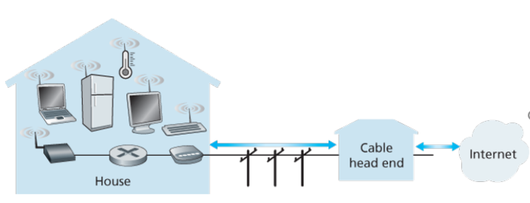
Fig 1.3 Typical Home Network
    - Physical Media

- Transmission media is a communication channel that carries the information from the sender to the receiver.
- Data is transmitted through the electromagnetic signals.
- The main functionality of the transmission media is to carry the information in the form of bits (Either as Electrical signals or Light pulses).
- It is a physical path between transmitter and receiver in data communication.

- The characteristics and quality of data transmission are determined by the characteristics of medium and signal.

Transmission media is of two types : Guided Media (Wired) and UnGuided Media (wireless).
- In guided (wired) media, medium characteristics are more important whereas, in unguided (wireless) media, signal characteristics are more important.
- Different transmission media have different properties such as bandwidth, delay, cost and ease of installation and maintenance.
- The transmission media is available in the lowest layer of the OSI reference model, i.e., Physical layer.

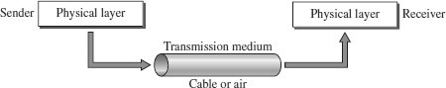

FACTORS FOR DESIGNING THE TRANSMISSION MEDIA
- Bandwidth: All the factors are remaining constant, the greater the bandwidth of a medium, the higher the data transmission rate of a signal.
- Transmission impairment: When the received signal is not identical to the transmitted one due to the transmission impairment. The quality of the signals will get destroyed due to transmission impairment.
- Interference: An interference is defined as the process of disrupting a signal when it travels over a communication medium on the addition of some unwanted signal.

CAUSES OF TRANSMISSION IMPAIRMENT
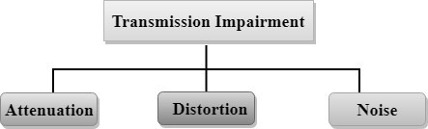
- Attenuation: Attenuation means the loss of energy, i.e., the strength of the signal decreases with increasing the distance which causes the loss of energy.
- Distortion: Distortion occurs when there is a change in the shape of the signal. This type of distortion is examined from different signals having different frequencies. Each frequency component has its own propagation speed, so they reach at a different time which leads to the delay distortion.

- Noise: When data is travelled over a transmission medium, some unwanted signal is added to it which creates the noise.
TYPES / CLASSES OF TRANSMISSION MEDIA
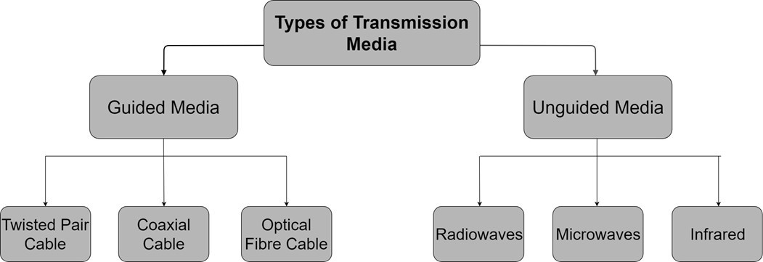

GUIDED MEDIA
- It is defined as the physical medium through which the signals are transmitted.
- It is also known as Bounded media.
- Types of Guided media: Twisted Pair Cable, Coaxial Cable , Fibre Optic Cable

TWISTED PAIR CABLE
- Twisted pair is a physical media made up of a pair of cables twisted with each other.
- A twisted pair cable is cheap as compared to other transmission media.
- Installation of the twisted pair cable is easy, and it is a lightweight cable.
- The frequency range for twisted pair cable is from 0 to 3.5KHz.
- A twisted pair consists of two insulated copper wires arranged in a regular spiral pattern.
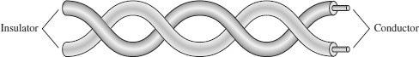

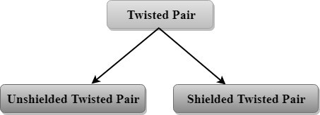

Unshielded Twisted Pair
An unshielded twisted pair is widely used in telecommunication.
Following are the categories of the unshielded twisted pair cable:
- Category 1: Suports low-speed data.
- Category 2: It can support upto 4Mbps.
- Category 3: It can support upto 16Mbps.
- Category 4: It can support upto 20Mbps.
- Category 5: It can support upto 200Mbps.
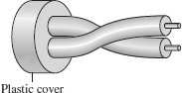

Advantages :
- It is cheap.
- Installation of the unshielded twisted pair is easy.
- It can be used for high-speed LAN.

Disadvantage:
- This cable can only be used for shorter distances because of attenuation.

Shielded Twisted Pair
A shielded twisted pair is a cable that contains the mesh surrounding the wire that allows the higher transmission rate.
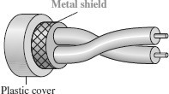

Advantages :
- The cost of the shielded twisted pair cable is not very high and not very low.
- Installation of STP is easy.
- It has higher capacity as compared to unshielded twisted pair cable.
- It has a higher attenuation.
- It is shielded that provides the higher data transmission rate.

Disadvantages:
- It is more expensive as compared to UTP and coaxial cable.
- It has a higher attenuation rate.

COAXIAL CABLE
- Coaxial cable(Coax) is a very commonly used transmission media, for example, TV wire is usually a coaxial cable.
- The name of the cable is coaxial as it contains two conductors parallel to each other.
- It has a higher frequency as compared to Twisted pair cable.
- The inner conductor of the coaxial cable is made up of copper, and the outer conductor is made up of copper mesh.
- The middle core is made up of non-conductive cover that separates the inner conductor from the outer conductor.
- The middle core is responsible for the data transferring whereas the copper mesh prevents from the EMI(Electromagnetic interference).
- Common applications of coaxial cable are Cable TV networks and traditional Ethernet LANs.
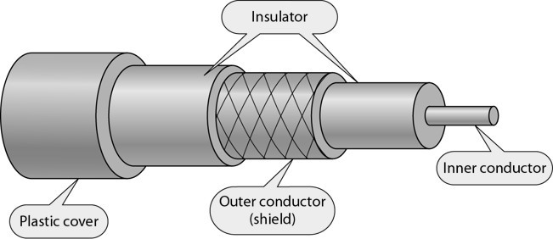

Coaxial Cable Standards
- Coaxial cables are categorized by their Radio Government (RG) ratings.
- Each RG number denotes a unique set of physical specifications, including the wire gauge of the inner conductor, the thickness and type of the inner insulator, the construction of the shield, and the size and type of the outer casing.
- Each cable defined by an RG rating is adapted for a specialized function.
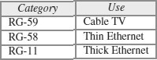

Types of Coaxial cable :
- Baseband transmission: It is defined as the process of transmitting a single signal at high speed.
- Broadband transmission: It is defined as the process of transmitting multiple
signals simultaneously.

Advantages :
  - The data can be transmitted at high speed.
  - It has better shielding as compared to twisted pair cable.
  - It provides higher bandwidth.

Disadvantages :
  - It is more expensive as compared to twisted pair cable.
  - If any fault occurs in the cable causes the failure in the entire network.

FIBRE OPTIC CABLE
  - Fibre optic cable is a cable that uses electrical signals for communication.
  - Fibre optic is a cable that holds the optical fibres coated in plastic that are used to send the data by pulses of light.
  - The plastic coating protects the optical fibres from heat, cold, electromagnetic interference from other types of wiring.
  - Fibre optics provide faster data transmission than copper wires.

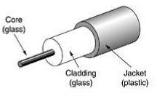
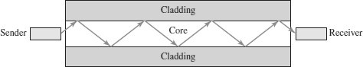

Basic elements of Fibre optic cable:
  - Core: The optical fibre consists of a narrow strand of glass or plastic known as a core. A core is a light transmission area of the fibre. The more the area of the core, the more light will be transmitted into the fibre.
  - Cladding: The concentric layer of glass is known as cladding. The main functionality of the cladding is to provide the lower refractive index at the core interface as to cause the reflection within the core so that the light waves are transmitted through the fibre.
  - Jacket: The protective coating consisting of plastic is known as a jacket. The main purpose of a jacket is to preserve the fibre strength, absorb shock and extra fibre protection.

Advantages:
  - Greater Bandwidth
  - Less signal attenuation
  - Immunity to electromagnetic interference
  - Resistance to corrosive materials

  - Light weight
  - Greater immunity to tapping

Disadvantages :
  - Requires Expertise for Installation and maintenance
  - Unidirectional light propagation.
  - Higher Cost.

Propagation Modes of Fibre Optics
- Current technology supports two modes (multimode and single mode) for propagating light along optical channels, each requiring fiber with different physical characteristics.
- Multimode can be implemented in two forms: step-index or graded-index.
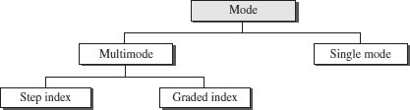

Multimode Propagation
- Multimode is so named because multiple beams from a light source move through the core in different paths.
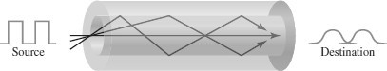
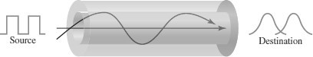
- How these beams move within the cable depends on the structure of the core.
- The multimode graded-index fiber, decreases this distortion of the signal through the cable.
- The word index here refers to the index of refraction.
- The index of refraction is related to density.
- A graded index fiber, therefore, is one with varying densities.
- Density is highest at the center of the core and decreases gradually to its lowest at the edge.
Multimode Graded-index fiber
- In multimode step-index fiber, the density of the core remains constant from the center to the edges.
- A beam of light moves through this constant density in a straight line until it reaches the interface of the core and the cladding.
- At the interface, there is an abrupt change due to a lower density; this alters the angle of the beam’s motion.
◻ The term step-index refers to the suddenness of this change, which contributes to the distortion of the signal as it passes through the fiber.
Multimode Step-index fiber

Single-Mode Propagation
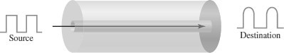
- Single-mode uses step-index fiber and a highly focused source of light that limits beams to a small range of angles, all close to the horizontal.
- The single-mode fiber itself is manufactured with a much smaller diameter than that of multimode fiber, and with substantially lower density (index of refraction).
- The decrease in density results in a critical angle that is close enough to 90° to make the propagation of beams almost horizontal.
- In this case, propagation of different beams is almost identical, and delays are negligible. All the beams arrive at the destination “together” and can be recombined with little distortion to the signal.

UNGUIDED MEDIA
- An unguided transmission transmits the electromagnetic waves without using any physical medium. Therefore it is also known as wireless transmission.
- In unguided media, air is the media through which the electromagnetic energy can flow easily.
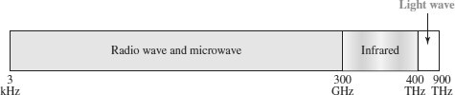

- Unguided transmission is broadly classified into three categories :
Radio Waves, Microwaves , Infrared

RADIO WAVES
  - Radio waves are the electromagnetic waves that are transmitted in all the directions of free space.
  - Radio waves are omnidirectional, i.e., the signals are propagated in all the directions.
  - The range in frequencies of radio waves is from 3Khz to 1Ghz.
  - In the case of radio waves, the sending and receiving antenna are not aligned, i.e., the wave sent by the sending antenna can be received by any receiving antenna.
  - An example of the radio wave is FM radio.

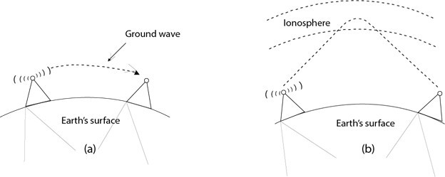

Applications of Radio waves:
  - A Radio wave is useful for multicasting when there is one sender and many receivers.
  - An FM radio, television, cordless phones are examples of a radio wave.

Advantages of Radio waves:
  - Radio transmission is mainly used for wide area networks and mobile cellular phones.
  - Radio waves cover a large area, and they can penetrate the walls.
  - Radio transmission provides a higher transmission rate.

MICROWAVES
Microwaves are of two types - Terrestrial microwave & Satellite microwave

Terrestrial Microwave
  - Terrestrial Microwave transmission is a technology that transmits the focused beam of a radio signal from one ground-based microwave transmission antenna to another.
  - Microwaves are the electromagnetic waves having the frequency in the range from 1GHz to 300 GHz.
  - Microwaves are unidirectional as the sending and receiving antenna is to be aligned, i.e., the waves sent by the sending antenna are narrowly focused.
  - In this case, antennas are mounted on the towers to send a beam to another antenna which is km away.
  - It works on the line of sight transmission, i.e., the antennas mounted on the towers are at the direct sight of each other.
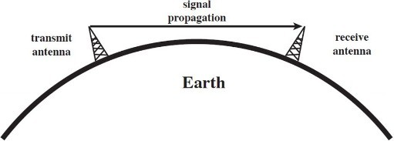

Characteristics of Terrestrial Microwave:
  - Frequency range: The more commonly used frequency range of terrestrial microwave is from 4-6 GHz to 21-23 GHz.
  - Bandwidth: It supports the bandwidth from 1 to 10 Mbps.
  - Short distance: It is inexpensive for short distance.
  - Long distance: It is expensive as it requires a higher tower for a longer distance.
  - Attenuation: Attenuation means loss of signal. It is affected by environmental conditions and antenna size.

Advantages of Terrestrial Microwave:
  - Microwave transmission is cheaper than using cables.
  - It is free from land acquisition as it does not require any land for the installation of cables.
  - Microwave transmission provides an easy communication in terrains as the installation of cable in terrain is quite a difficult task.
  - Communication over oceans can be achieved by using microwave transmission.

Disadvantages of Terrestrial Microwave:
  - Eavesdropping.
  - Out of phase signal
  - Susceptible to weather condition
  - Bandwidth limited

Satellite Microwave
  - A satellite is a physical object that revolves around the earth at a known height.
  - Satellite communication is more reliable nowadays as it offers more flexibility than cable and fibre optic systems.
  - We can communicate with any point on the globe by using satellite communication.
  - The satellite accepts the signal that is transmitted from the earth station, and it amplifies the signal. The amplified signal is retransmitted to another earth station.
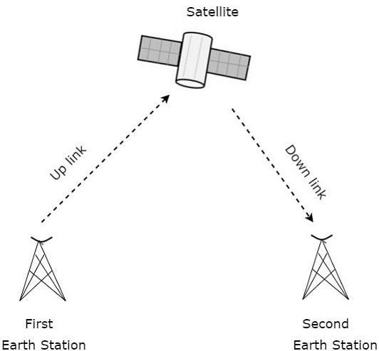

Advantages of Satellite Microwave:
  - The coverage area of a satellite microwave is more than the terrestrial microwave.
  - The transmission cost of the satellite is independent of the distance from the centre of the coverage area.
  - Satellite communication is used in mobile and wireless communication applications.
  - It is easy to install.
  - It is used in a wide variety of applications such as weather forecasting, radio/TV signal broadcasting, mobile communication, etc.

Disadvantages of Satellite Microwave:
  - Satellite designing and development requires more time and higher cost.
  - The Satellite needs to be monitored and controlled on regular periods so that it remains in orbit.
  - The life of the satellite is about 12-15 years. Due to this reason, another launch of the satellite has to be planned before it becomes non-functional.

INFRARED WAVES
  - An infrared transmission is a wireless technology used for communication over short ranges.
  - The frequency of the infrared in the range from 300 GHz to 400 THz.
  - It is used for short-range communication such as data transfer between two cell phones, TV remote operation, data transfer between a computer and cell phone and devices that resides in the same closed area.

Characteristics of Infrared:
  - It supports high bandwidth, and hence the data rate will be very high.
  - Infrared waves cannot penetrate the walls. Therefore, the infrared communication in one room cannot be interrupted by the nearby rooms.
  - An infrared communication provides better security with minimum interference.
  - Infrared communication is unreliable outside the building because the sun rays will interfere with the infrared waves.

1.1.4 Network Core
  - The technique of transferring the information from one computer to another is known as switching.
  - Switching in a computer network is achieved by using switches.
  - A switch is a small hardware device which is used to join multiple computers together with one local area network (LAN).

  - Switches are devices capable of creating temporary connections between two or more devices linked to the switch.
  - Switches are used to forward the packets based on MAC addresses.
  - A Switch is used to transfer the data only to the device that has been addressed. It verifies the destination address to route the packet appropriately.
  - It is operated in full duplex mode.
  - It does not broadcast the message as it works with limited bandwidth.

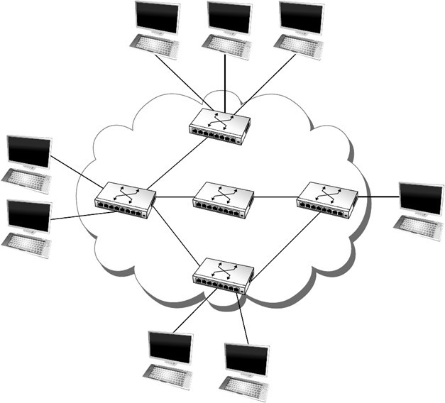

Advantages of Switching:
  - Switch increases the bandwidth of the network.
  - It reduces the workload on individual PCs as it sends the information to only that device which has been addressed.
  - It increases the overall performance of the network by reducing the traffic on the network.
  - There will be less frame collision as switch creates the collision domain for each connection.

Disadvantages of Switching:
  - A Switch is more expensive than network bridges.
  - A Switch cannot determine the network connectivity issues easily.
  - Proper designing and configuration of the switch are required to handle multicast packets.
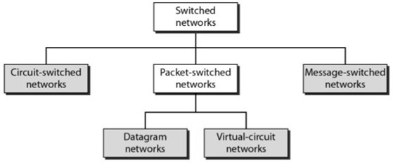
Types of Switching

CIRCUIT SWITCHING
  - Circuit switching is a switching technique that establishes a dedicated path between sender and receiver.
  - In the Circuit Switching Technique, once the connection is established then the dedicated path will remain to exist until the connection is terminated.
  - Circuit switching in a network operates in a similar way as the telephone works.
  - A complete end-to-end path must exist before the communication takes place.
  - In case of circuit switching technique, when any user wants to send the data, voice, video, a request signal is sent to the receiver then the receiver sends back the acknowledgment to ensure the availability of the dedicated path. After receiving the acknowledgment, dedicated path transfers the data.
  - Circuit switching is used in public telephone network. It is used for voice transmission.
  - Fixed data can be transferred at a time in circuit switching technology.

Phases in Circuit Switching
Communication through circuit switching has 3 phases:
- Connection Setup / Establishment - In this phase, a dedicated circuit is established from the source to the destination through a number of intermediate switching centres. The sender and receiver transmits communication signals to request and acknowledge establishment of circuits.
- Data transfer - Once the circuit has been established, data and voice are transferred from the source to the destination. The dedicated connection remains as long as the end parties communicate.
- Connection teardown / Termination - When data transfer is complete, the connection is relinquished. The disconnection is initiated by any one of the user. Disconnection involves removal of all intermediate links from the sender to the receiver.
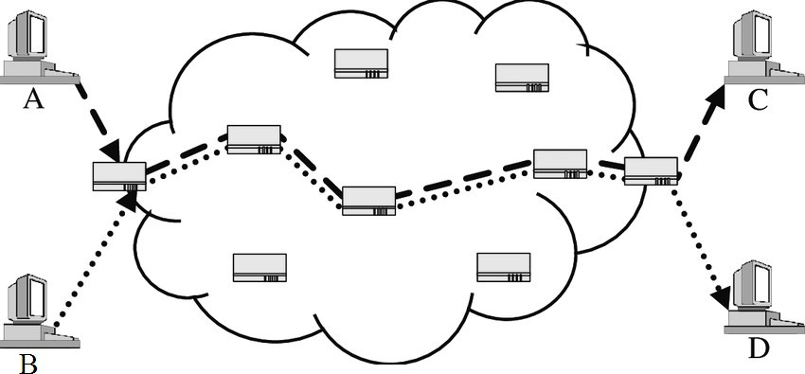

Advantages
  - It is suitable for long continuous transmission, since a continuous transmission route is established, that remains throughout the conversation.
  - The dedicated path ensures a steady data rate of communication.
  - No intermediate delays are found once the circuit is established. So, they are suitable for real time communication of both voice and data transmission.

Disadvantages
  - Circuit switching establishes a dedicated connection between the end parties. This dedicated connection cannot be used for transmitting any other data, even if the data load is very low.
  - Bandwidth requirement is high even in cases of low data volume.
  - There is underutilization of system resources. Once resources are allocated to a particular connection, they cannot be used for other connections.
  - Time required to establish connection may be high.
  - It is more expensive than other switching techniques as a dedicated path is required for each connection.

PACKET SWITCHING
- The packet switching is a switching technique in which the message is divided into smaller pieces and they are sent individually.
- The message splits into smaller pieces known as packets and packets are given a unique number to identify their order at the receiving end.
- Every packet contains some information in its headers such as source address, destination address and sequence number.
- Packets will travel across the network, taking the shortest path as possible.
- All the packets are reassembled at the receiving end in correct order.
- If any packet is missing or corrupted, then the message will be sent to resend the message.
- If the correct order of the packets is reached, then the acknowledgment message will be sent.
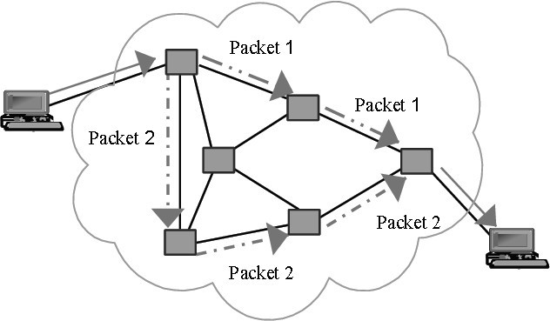

Advantages of Packet Switching:
- Cost-effective: In packet switching technique, switching devices do not require massive secondary storage to store the packets, so cost is minimized to some extent. Therefore, we can say that the packet switching technique is a cost- effective technique.
- Reliable: If any node is busy, then the packets can be rerouted. This ensures that the Packet Switching technique provides reliable communication.
- Efficient: Packet Switching is an efficient technique. It does not require any established path prior to the transmission, and many users can use the same communication channel simultaneously, hence makes use of available bandwidth very efficiently.

Disadvantages of Packet Switching:
- Packet Switching technique cannot be implemented in those applications that require low delay and high-quality services.
- The protocols used in a packet switching technique are very complex and requires high implementation cost.
- If the network is overloaded or corrupted, then it requires retransmission of lost packets. It can also lead to the loss of critical information if errors are nor recovered.

APPROACHES OF PACKET SWITCHING
There are two approaches to Packet Switching:
- Datagram Switching Approach
- Virtual Circuit Switching Approach

Datagram Switching
- It is a packet switching technology in which packet is known as a datagram, is considered as an independent entity.
- Each packet contains the information about the destination and switch uses this information to forward the packet to the correct destination.
- The packets are reassembled at the receiving end in correct order.
- In Datagram Packet Switching technique, the path is not fixed.
- Intermediate nodes take the routing decisions to forward the packets.
- Datagram Packet Switching is also known as connectionless switching.
- There are no setup or teardown phases.
- Each packet is treated the same by a switch regardless of its source or destination.

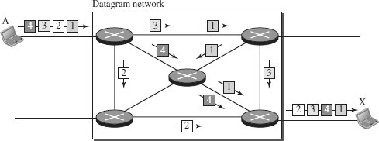
In this example, all four packets (or datagrams) belong to the same message, but may travel different paths to reach their destination.

Routing Table
  - In this type of network, each switch has a routing table which is based on the destination address. The routing tables are dynamic and are updated periodically.
  - The destination addresses and the corresponding forwarding output ports are recorded in the tables.
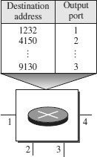

Delay in a datagram network
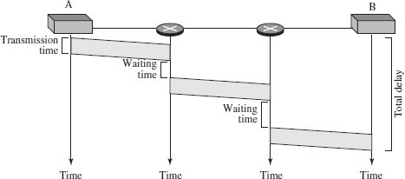

  - The packet travels through two switches.
  - There are three transmission times (3T),three propagation delays (slopes 3t of the lines), and two waiting times (w1 + w2).
  - We ignore the processing time in each switch.

Total delay = 3T + 3t + w1 + w2

Virtual Circuit Switching
- Virtual Circuit Switching is also known as connection-oriented switching.
- In the case of Virtual circuit switching, a virtual connection is established before the messages are sent.
- Call request and call accept packets are used to establish the connection between sender and receiver.
- In this case, the path is fixed for the duration of a logical connection.

Virtual Circuit Identifier (VCI)
  - A virtual circuit identifier (VCI) uniquely identifies the connection at this switch.
  - A VCI is a small number that has only switch scope; it is used by a frame between two switches.
  - When a frame arrives at a switch, it has a VCI; when it leaves, it has a different VCI.
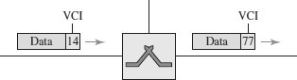

Virtual Circuit Table
    - Every Virtual Circuit (VC) maintains a table called Virtual Circuit table.
    - One entry in the VC table on a single switch contains the following :
    - An incoming interface on which packets for this VC arrive at the switch
    - An incoming VCI that will be used for incoming packets
    - An outgoing interface in which packets for this VC leave the switch
    - A outgoing VCI that will be used for outgoing packets

Example :
Source A sends a frame to Source B through Switch 1, Switch 2 and Switch 3.
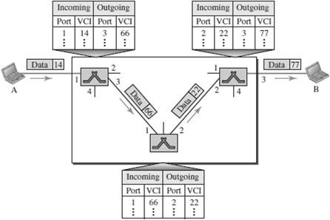

Types of Virtual Circuits
There are two broad classes of Virtual Circuits. They are

PVC – Permanent Virtual Circuit
  - Network Administrator will configure the state
  - The virtual circuit is permanent

SVC – Switched Virtual Circuit
  - A host can send messages into the network to cause the state to be established. This is referred as signaling.
  - A host may set up and delete such a VC dynamically without the involvement of a network administrator

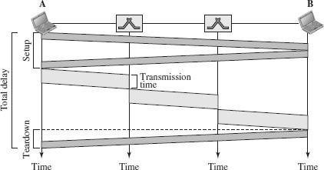
Delay in Virtual-Circuit Networks

  - The packet is traveling through two switches (routers).
  - There are three transmission times (3T ), three propagation times (3t), data transfer depicted by the sloping lines, a setup delay (which includes transmission and propagation in two directions), and a teardown delay (which includes transmission and propagation in one direction).
Total delay = 3T + 3t + Setup delay + Teardown delay

COMPARISON – CIRCUIT SWITCHING AND PACKET SWITCHING

CIRCUIT | PACKET SWITCHING
SWITCHING | Virtual Circuit Switching | Datagram Switching
Connection oriented | Connection oriented | Connection less
Ensures in order delivery | Ensures in order delivery | Packets may be delivered out of order
No reordering is required | No reordering is required | Reordering is required
A dedicated path exists for data transfer | A dedicated path exists for data transfer | No dedicated path exists for data transfer
All the packets take the same path | All the packets take the same path | All the packets may not take the same path
Resources are allocated before data transfer | Resources are allocated on demand using 1st packet | No resources are allocated
Stream oriented | Packet oriented | Packet oriented
Fixed bandwidth | Dynamic Bandwidth | Dynamic bandwidth
Reliable | Reliable | Unreliable
No overheads | Less overheads | Higher overheads
Implemented at physical layer | Implemented at data link layer | Implemented at network layer
Inefficient in terms of resource utilization | Provides better efficiency than circuit switched systems | Provides better efficiency than message switched systems
Example- Telephone systems | Examples- X.25, Frame relay | Example- Internet

MESSAGE SWITCHING
- Message Switching is a switching technique in which a message is transferred as a complete unit and routed through intermediate nodes at which it is stored and forwarded.
- In Message Switching technique, there is no establishment of a dedicated path between the sender and receiver.
- The destination address is appended to the message. Message Switching provides a dynamic routing as the message is routed through the intermediate nodes based on the information available in the message.
- Message switches are programmed in such a way so that they can provide the most efficient routes.
- Each and every node stores the entire message and then forward it to the next node. This type of network is known as store and forward network.
- Message switching treats each message as an independent entity.
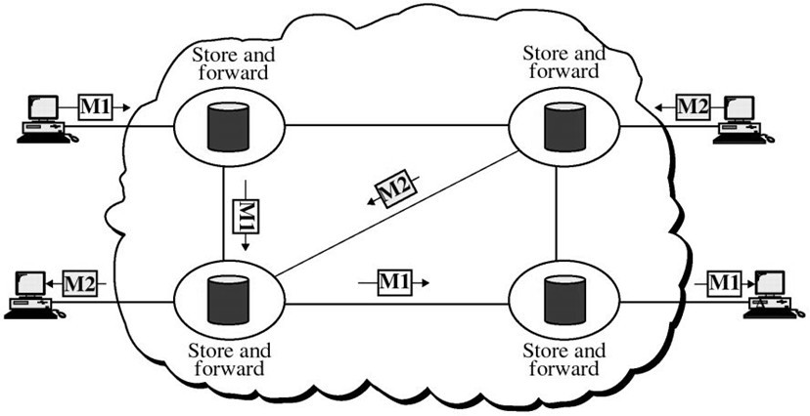

  - Layered Architecture
- networking, a protocol defines the rules that both the sender and receiver and all intermediate devices need to follow to be able to communicate effectively.
- A protocol provides a communication service that the process use to exchange messages.
- When communication is simple, we may need only one simple protocol.
- When the communication is complex, we may need to divide the task between different layers, in which case we need a protocol at each layer, or protocol layering.
- Protocol layering is that it allows us to separate the services from the implementation.
- A layer needs to be able to receive a set of services from the lower layer and to give the services to the upper layer.
- Any modification in one layer will not affect the other layers.

Basic Elements of Layered Architecture
- Service: It is a set of actions that a layer provides to the higher layer.
- Protocol: It defines a set of rules that a layer uses to exchange the information with peer entity. These rules mainly concern about both the contents and order of the messages used.
- Interface: It is a way through which the message is transferred from one layer to another layer.

Features of Protocol Layering
- It decomposes the problem of building a network into more manageable components.

It provides a more modular design.

Principles of Protocol Layering
- The first principle dictates that if we want bidirectional communication, we need to make each layer so that it is able to perform two opposite tasks, one in each direction.
- The second principle that we need to follow in protocol layering is that the two objects under each layer at both sites should be identical.

Protocol Graph
  - The set of protocols that make up a network system is called a protocol graph.
  - The nodes of the graph correspond to protocols, and the edges represent a dependence relation.
  - For example, the Figure below illustrates a protocol graph consists of protocols RRP (Request/Reply Protocol) and MSP (Message Stream Protocol) implement two different types of process-to-process channels, and both depend on the HHP (Host-to- Host Protocol) which provides a host-to-host connectivity service
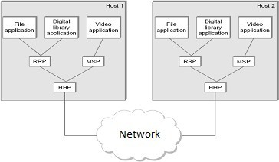

OSI MODEL
- OSI stands for Open System Interconnection.
- It is a reference model that describes how information from a software application in one computer moves through a physical medium to the software application in another computer.
- OSI consists of seven layers, and each layer performs a particular network function.
- OSI model was developed by the International Organization for Standardization (ISO) in 1984.
- It is considered as an architectural model for the inter-computer communications.
- OSI model divides the whole task into seven smaller and manageable tasks. Each layer is assigned a particular task.
- Each layer is self-contained, so that task assigned to each layer can be performed independently.
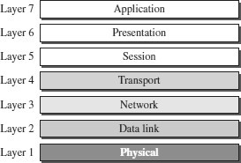

ORGANIZATION OF THE OSI LAYERS

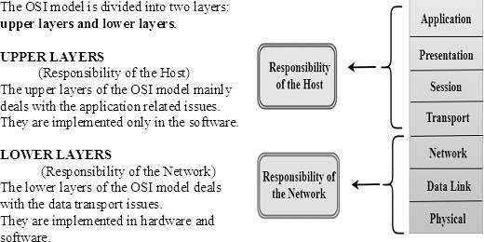

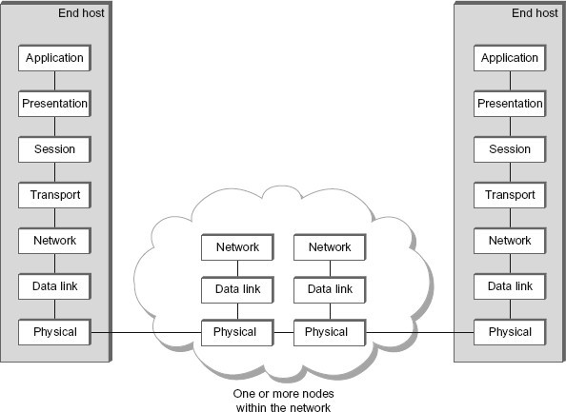

FUNCTIONS OF THE OSI LAYERS

PHYSICAL LAYER
The physical layer coordinates the functions required to transmit a bit stream over a physical medium.
The physical layer is concerned with the following functions:
  - Physical characteristics of interfaces and media - The physical layer defines the characteristics of the interface between the devices and the transmission medium.
  - Representation of bits - To transmit the stream of bits, it must be encoded to signals. The physical layer defines the type of encoding.
  - Signals: It determines the type of the signal used for transmitting the information.
  - Data Rate or Transmission rate - The number of bits sent each second –is also defined by the physical layer.
  - Synchronization of bits - The sender and receiver must be synchronized at the bit level. Their clocks must be synchronized.
  - Line Configuration - In a point-to-point configuration, two devices are connected together through a dedicated link. In a multipoint configuration, a link is shared between several devices.
  - Physical Topology - The physical topology defines how devices are connected to make a network. Devices can be connected using a mesh, bus, star or ring topology.
  - Transmission Mode - The physical layer also defines the direction of transmission between two devices: simplex, half-duplex or full-duplex.

DATA LINK LAYER
It is responsible for transmitting frames from one node to the next node. The other responsibilities of this layer are
  - Framing - Divides the stream of bits received into data units called frames.
  - Physical addressing – If frames are to be distributed to different systems on the network , data link layer adds a header to the frame to define the sender and receiver.
  - Flow control- If the rate at which the data are absorbed by the receiver is less than the rate produced in the sender ,the Data link layer imposes a flow control mechanism.
  - Error control- Used for detecting and retransmitting damaged or lost frames and to prevent duplication of frames. This is achieved through a trailer added at the end of the frame.
  - Medium Access control -Used to determine which device has control over the link at any given time.

NETWORK LAYER
This layer is responsible for the delivery of packets from source to destination.
It determines the best path to move data from source to the destination based on the network conditions, the priority of service, and other factors.
The other responsibilities of this layer are
  - Logical addressing - If a packet passes the network boundary, we need another addressing system for source and destination called logical address. This addressing is used to identify the device on the internet.
  - Routing – Routing is the major component of the network layer, and it determines the best optimal path out of the multiple paths from source to the destination.

TRANSPORT LAYER
It is responsible for Process to Process delivery. That is responsible for source-to- destination (end-to-end) delivery of the entire message, It also ensures whether the message arrives in order or not.
The other responsibilities of this layer are
  - Port addressing / Service Point addressing - The header includes an address called port address / service point address. This layer gets the entire message to the correct process on that computer.
  - Segmentation and reassembly - The message is divided into segments and each segment is assigned a sequence number. These numbers are arranged correctly on the arrival side by this layer.
  - Connection control - This can either be connectionless or connection oriented.
    - The connectionless treats each segment as an individual packet and delivers to the destination.
    - The connection-oriented makes connection on the destination side before the delivery. After the delivery the termination will be terminated.
  - Flow control - The transport layer also responsible for flow control but it is performed end-to-end rather than across a single link.
  - Error Control - Error control is performed end-to-end rather than across the single link..

SESSION LAYER
This layer establishes, manages and terminates connections between applications. The other responsibilities of this layer are
  - Dialog control - Session layer acts as a dialog controller that creates a dialog between two processes or we can say that it allows the communication between two processes which can be either half-duplex or full-duplex.
  - Synchronization- Session layer adds some checkpoints when transmitting the data in a sequence. If some error occurs in the middle of the transmission of data, then the transmission will take place again from the checkpoint. This process is known as Synchronization and recovery.

PRESENTATION LAYER
It is concerned with the syntax and semantics of information exchanged between two systems.
The other responsibilities of this layer are
  - Translation – Different computers use different encoding system, this layer is responsible for interoperability between these different encoding methods. It will change the message into some common format.
  - Encryption and decryption-It means that sender transforms the original information to another form and sends the resulting message over the n/w. and vice versa.
  - Compression and expansion-Compression reduces the number of bits contained in the information particularly in text, audio and video.

APPLICATION LAYER
This layer enables the user to access the network. It handles issues such as network transparency, resource allocation, etc. This allows the user to log on to remote user.
The other responsibilities of this layer are
  - FTAM (File Transfer, Access, Management) - Allows user to access files in a remote host.
  - Mail services - Provides email forwarding and storage.
  - Directory services - Provides database sources to access information about various sources and objects.

TCP / IP PROTOCOL SUITE
- The TCP/IP architecture is also called as Internet architecture.
- It is developed by the US Defense Advanced Research Project Agency (DARPA) for its packet switched network (ARPANET).
- TCP/IP is a protocol suite used in the Internet today.
- It is a 4-layer model. The layers of TCP/IP are
- Application layer
- Transport Layer (TCP/UDP)
- Internet Layer
- Network Interface Layer
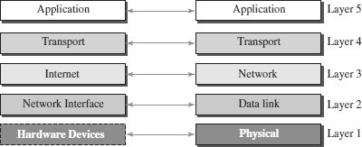

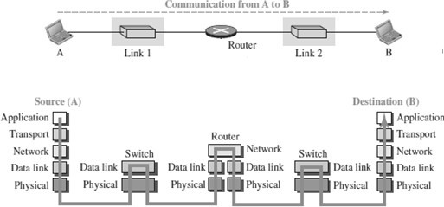

APPLICATION LAYER
- An application layer incorporates the function of top three OSI layers. An application layer is the topmost layer in the TCP/IP model.
- It is responsible for handling high-level protocols, issues of representation.
- This layer allows the user to interact with the application.
- When one application layer protocol wants to communicate with another application layer, it forwards its data to the transport layer.
- Protocols such as FTP, HTTP, SMTP, POP3, etc running in the application layer provides service to other program running on top of application layer

TRANSPORT LAYER
- The transport layer is responsible for the reliability, flow control, and correction of data which is being sent over the network.
- The two protocols used in the transport layer are User Datagram protocol and Transmission control protocol.
  - UDP – UDP provides connectionless service and end-to-end delivery of transmission. It is an unreliable protocol as it discovers the errors but not specify the error.
  - TCP – TCP provides a full transport layer services to applications. TCP is a reliable protocol as it detects the error and retransmits the damaged frames.

INTERNET LAYER
- The internet layer is the second layer of the TCP/IP model.
- An internet layer is also known as the network layer.
- The main responsibility of the internet layer is to send the packets from any network, and they arrive at the destination irrespective of the route they take.
- Internet layer handle the transfer of information across multiple networks through router and gateway .
- IP protocol is used in this layer, and it is the most significant part of the entire TCP/IP suite.

NETWORK INTERFACE LAYER
- The network interface layer is the lowest layer of the TCP/IP model.
- This layer is the combination of the Physical layer and Data Link layer defined in the OSI reference model.
- It defines how the data should be sent physically through the network.
- This layer is mainly responsible for the transmission of the data between two devices on the same network.
- The functions carried out by this layer are encapsulating the IP datagram into frames transmitted by the network and mapping of IP addresses into physical addresses.
- The protocols used by this layer are Ethernet, token ring, FDDI, X.25, frame relay.

COMPARISON - OSI MODEL AND TCP/IP MODEL
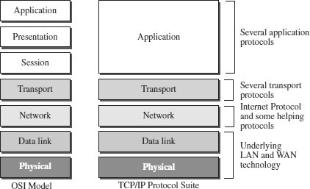
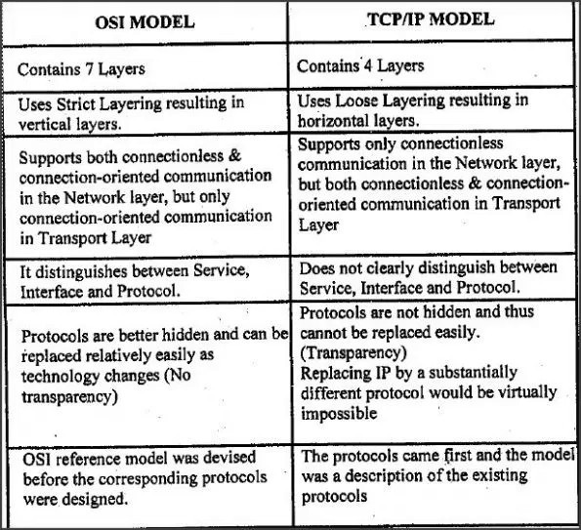

  - Networking Devices

(Hub, Repeater, Bridge, Switch, Router and Gateways)
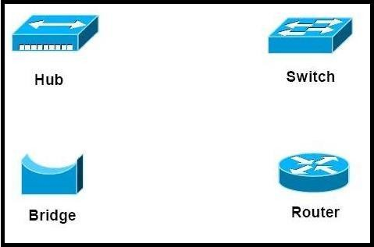
- Repeater – A repeater operates at the physical layer. Its job is to regenerate the signal over the same network before the signal becomes too weak or corrupted so as to extend the length to which the signal can be transmitted over the same network. An important point to be noted about repeaters is that they do no amplify the signal. When the signal becomes weak, they copy the signal bit by bit and regenerate it at the original strength. It is a 2 port device.
A single Ethernet segment can have a maximum length of 500 meters with a maximum of 100 stations (in a cheapernet segment it is 185m). To extend the length of the network, a repeater may be used as shown in Fig. 6.1.1. Functionally, a repeater can be considered as two transceivers joined together and connected to two different segments of coaxial cable. The repeater passes the digital signal bit-by-bit in both directions between the two segments. As the signal passes through a repeater, it is amplified and regenerated at the other end. The repeater does not isolate one segment from the other, if there is a collision on one segment, it is regenerated on the other segment. Therefore, the two segments form a single LAN and it is transparent to rest of the system. Ethernet allows five segments to be used in cascade to have a maximum network span of 2.5 km. With reference of the ISO model, a repeater is considered as a level-1 relay as depicted in Fig. 6.1.2. It simply repeats, retimes and amplifies the bits it receives. The repeater is merely used to extend the span of a single LAN. Important features of a repeater are as follows:
  - A repeater connects different segments of a LAN
  - A repeater forwards every frame it receives
  - A repeater is a regenerator, not an amplifier
  - It can be used to create a single extended LAN

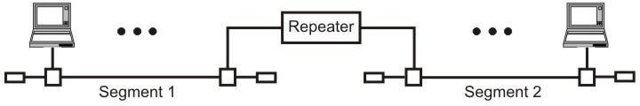

Figure Repeater connecting two LAN segments

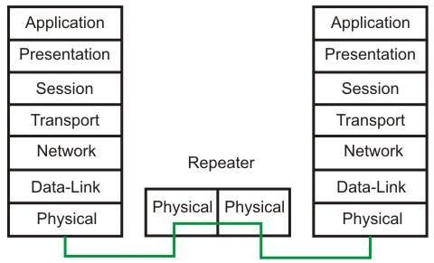

Figure Operation of a repeater as a level-1 relay

- Hub – A hub is basically a multiport repeater. A hub connects multiple wires coming from different branches, for example, the connector in star topology which connects different stations. Hubs cannot filter data, so data packets are sent to all connected devices. In other words, collision domain of all hosts connected through Hub remains one. Also, they do not have intelligence to find out best path for data packets which leads to inefficiencies and wastage.

Hub is a generic term, but commonly refers to a multiport repeater. It can be used to create multiple levels of hierarchy of stations. The stations connect to the hub with RJ-45 connector having maximum segment length is 100 meters. This type of interconnected set of stations is easy to maintain and diagnose. Figure shows how several hubs can be connected in a hierarchical manner to realize a single LAN of bigger size with a large number of nodes.
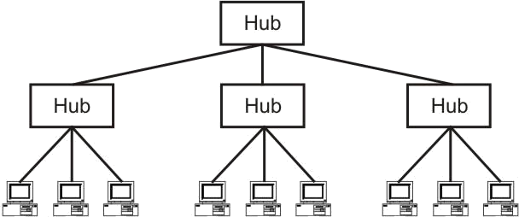
Figure Hub as a multi-port repeater can be connected in a hierarchical manner to form a single LAN with many nodes
- Bridge – A bridge operates at data link layer. A bridge is a repeater, with add on functionality of filtering content by reading the MAC addresses of source and destination. It is also used for interconnecting two LANs working on the same protocol. It has a single input and single output port, thus making it a 2 port device.
The device that can be used to interconnect two separate LANs is known as a bridge. It is commonly used to connect two similar or dissimilar LANs as shown in Fig. 6.1.4. The bridge operates in layer 2, that is data-link layer and that is why it is called level-2 relay with reference to the OSI model. It links similar or dissimilar LANs, designed to store and forward frames, it is protocol independent and transparent to the end stations. The flow of information through a bridge is shown in Fig. 6.1.5. Use of bridges offer a number of advantages, such as higher reliability, performance, security, convenience and larger geographic coverage. But, it is desirable that the quality of service (QOS) offered by a bridge should match that of a single LAN. The parameters that define the QOS include availability, frame mishaps, transit delay, frame lifetime, undetected bit errors, frame size and priority. Key features of a bridge are mentioned below:

  - A bridge operates both in physical and data-link layer
  - A bridge uses a table for filtering/routing
  - A bridge does not change the physical (MAC) addresses in a frame
  - Types of bridges:
o Transparent Bridges
o Source routing bridges

A bridge must contain addressing and routing capability. Two routing algorithms have been proposed for a bridged LAN environment. The first, produced as an extension of IEEE 802.1 and applicable to all IEEE 802 LANs, is known as transparent bridge. And the other, developed for the IEEE 802.5 token rings, is based on source routing approach. It applies to many types of LAN including token ring, token bus and CSMA/CD bus.

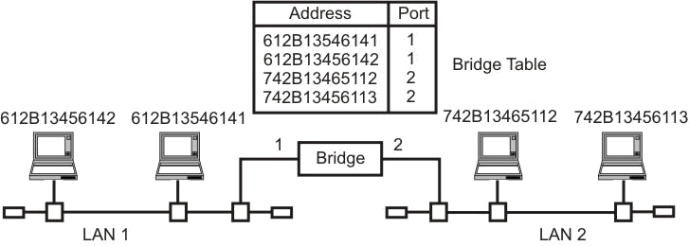

Figure A bridge connecting two separate LANs

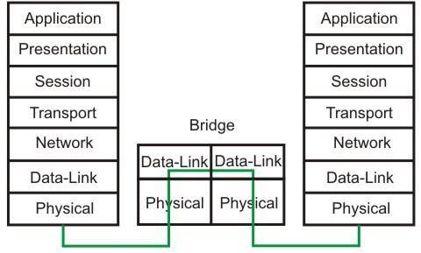
Figure Information flow through a bridge
- Switch – A switch is a multi port bridge with a buffer and a design that can boost its efficiency(large number of ports imply less traffic) and performance. Switch is data link layer device. Switch can perform error checking before forwarding data, that makes it very efficient as it does not forward packets that have errors and forward good packets selectively to correct port only. In other words, switch divides collision domain of hosts, butbroadcast domain remains same.

A switch is essentially a fast bridge having additional sophistication that allows faster processing of frames. Some of important functionalities are:

  - Ports are provided with buffer
  - Switch maintains a directory: #address - port#
  - Each frame is forwarded after examining the #address and forwarded to the proper port#
  - Three possible forwarding approaches: Cut-through, Collision-free and Fully- buffered as briefly explained below.

Cut-through: A switch forwards a frame immediately after receiving the destination address. As a consequence, the switch forwards the frame without collision and error detection.

Collision-free: In this case, the switch forwards the frame after receiving 64 bytes, which allows detection of collision. However, error detection is not possible because switch is yet to receive the entire frame.

Fully buffered: In this case, the switch forwards the frame only after receiving the entire frame. So, the switch can detect both collision and error free frames are forwarded.
Comparison between a switch and a hub

Although a hub and a switch apparently look similar, they have significant differences. As shown in Fig. , both can be used to realize physical star topology, the hubs works like a logical bus, because the same signal is repeated on all the ports. On the other hand, a switch functions like a logical star with the possibility of the communication of separate signals between any pair of port lines. As a consequence, all the ports of a hub belong to the same collision domain, and in case of a switch each port operates on separate collision domain. Moreover, in case of a hub, the bandwidth is shared by all the stations connected to all the ports. On the other hand, in case of a switch, each port has dedicated bandwidth. Therefore, switches can be used to increase the bandwidth of a hub-based network by replacing the hubs by switches.

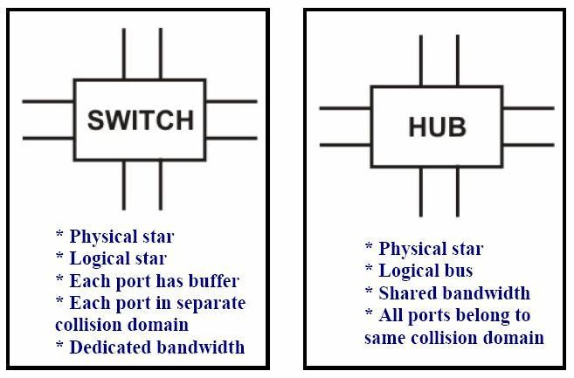

Figure Difference between a switch and a bridge

- Routers – A router is a device like a switch that routes data packets based on their IP addresses. Router is mainly a Network Layer device. Routers normally connect LANs and WANs together and have a dynamically updating routing table based on which they make decisions on routing the data packets. Router divide broadcast domains of hosts connected through it.

A router is used to route data packets between two networks. It reads the information in each packet to tell where it is going. If it is destined for an immediate network it has access to, it will strip the outer packet (IP packet for example), readdress the packet to the proper ethernet address, and transmit it on that network. If it is destined for another network and must be sent to another router, it will re-package the outer packet to be received by the next router and send it to the next router. Routing occurs at the network layer of the OSI model. They can connect networks with different architectures such as Token Ring and Ethernet. Although they can transform information at the data link level, routers cannot transform information from one data format such as TCP/IP to another such as IPX/SPX. Routers do not send broadcast packets or corrupted packets. If the routing table does not indicate the proper address of a packet, the packet is discarded. There are two types of routers:

- Static routers - Are configured manually and route data packets based on information in a router table.
- Dynamic routers - Use dynamic routing algorithms. There are two types of algorithms:
  - Distance vector - Based on hop count, and periodically broadcasts the routing table to other routers which takes more network bandwidth especially with more routers. RIP uses distance vectoring. Does not work on WANs as well as it does on LANs.
  - Link state - Routing tables are broadcast at startup and then only when they change. The open shortest path first (OSPF) protocol uses the link state routing method to configure routes or distance vector algorithm (DVA).
Common routing protocols include:
- IS-IS -Intermediate system to intermediate system which is a routing protocol for the OSI suite of protocols.
- IPX - Internet Packet Exchange. Used on Netware systems.
- NLSP - Netware Link Services protocol - Uses OSPF algorithm and is replacing IPX to provide internet capability.
- RIP - Routing information protocol uses a distance vector algorithm.
There is a device called a brouter which will function similar to a bridge for network transport protocols that are not routable, and will function as a router for routable protocols. It functions at the network and data link layers of the OSI network model.

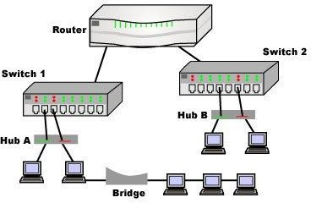
A router is considered as a layer-3 relay that operates in the network layer, that is it acts on network layer frames. It can be used to link two dissimilar LANs. A router isolates LANs in to subnets to manage and control network traffic. However, unlike bridges it is not transparent to end stations. A schematic diagram of the router is shown on Fig. A router has four basic components: Input ports, output ports, the routing processor and the switching fabric. The functions of the four components are briefly mentioned below.
- Input port performs physical and data-link layer functions of the router. As shown in Fig. 6.1.14 (a), the ports are also provided with buffer to hold the packet before forwarding to the switching fabric.
- Output ports, as shown in Fig., perform the same functions as the input ports, but in the reverse order.
- The routing processor performs the function of the network layer. The process involves table lookup.
- The switching fabric, shown in Fig. moves the packet from the input queue to the output queue by using specialized mechanisms. The switching fabric is realized with the help of multistage interconnection networks.
- Communication of a frame through a router is shown in Fig. 6.1.16.
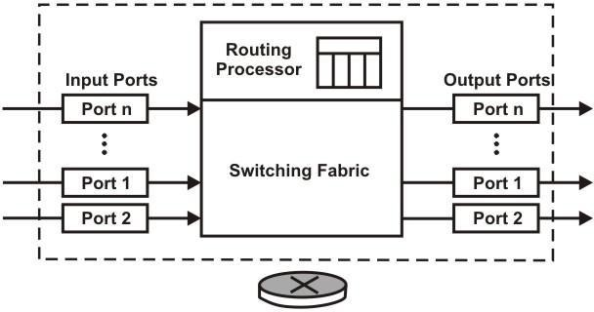
Figure Schematic diagram of a router
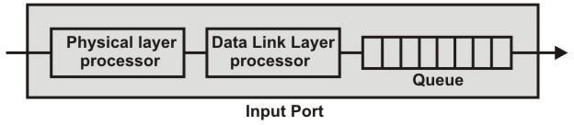
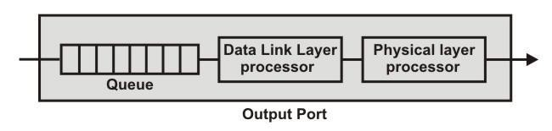
(a)

Figure 6.1.14 Schematic diagram of a router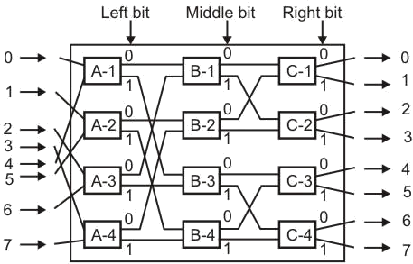
Figure Switching fabric of a router

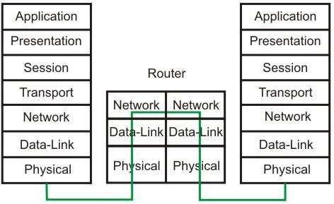

Figure Communication through a router

- Gateway – A gateway, as the name suggests, is a passage to connect two networks together that may work upon different networking models. They basically works as the messenger agents that take data from one system, interpret it, and transfer it to another system. Gateways are also called protocol converters and can operate at any network layer. Gateways are generally more complex than switch or router.
A gateway can translate information between different network data formats or network architectures. It can translate TCP/IP to AppleTalk so computers supporting TCP/IP can communicate with Apple brand computers. Most gateways operate at the application layer, but can operate at the network or session layer of the OSI model. Gateways will start at the lower level and strip information until it gets to the required level and repackage the information and work its way back toward the hardware layer of the OSI model. To confuse issues, when talking about a router that is used to interface to another network, the word gateway is often used. This does not mean the routing machine is a gateway as defined here, although it could be.
A gateway works above the network layer, such as application layer as shown in Fig. As a consequence, it is known as a Layer-7 relay. The application level gateways can look into the content application layer packets such as email before forwarding it to the other side. This property has made it suitable for use in Firewalls discussed in the next module.
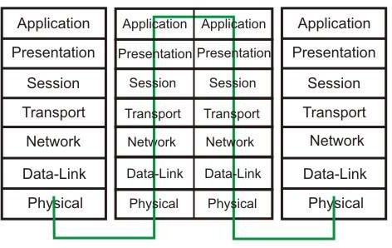
Figure Communication through a gateway
  - Performance Metrics

Network performance is measured in using:
Bandwidth, Throughput, Latency, Jitter, RoundTrip Time

BANDWIDTH
  - The bandwidth of a network is given by the number of bits that can be transmitted over the network in a certain period of time.
  - Bandwidth can be measured in two different values: bandwidth in hertz and bandwidth in bits per second.

Bandwidth in Hertz
- Bandwidth in hertz refers to the range of frequencies contained in a composite signal or the range of frequencies a channel can pass.

- For example, we can say the bandwidth of a subscriber telephone line is 4 kHz.

Bandwidth in Bits per Seconds
- Bandwidth in Bits per Seconds refers to the number of bits transmitted per second.
- For example, the bandwidth of a network is a maximum of 100 Mbps. This means that this network can send 100 Mbps.

Relationship
- There is an explicit relationship between the bandwidth in hertz and bandwidth in bits per second.
- Basically, an increase in bandwidth in hertz means an increase in bandwidth in bits per second.

THROUGHPUT
  - Throughput is a measure of how fast we can actually send data through a network.
  - Bandwidth in bits per second and throughput may seem to be same, but they are different.
  - A link may have a bandwidth of B bps, but we can only send T bps through this link. (T always less than B).
  - In other words, the bandwidth is a potential measurement of a link; the throughput is an actual measurement of how fast we can send data.
  - For example, we may have a link with a bandwidth of 1 Mbps, but the devices connected to the end of the link may handle only 200 kbps. This means that we cannot send more than 200 kbps through this link.

Problem :
A network with bandwidth of 10 Mbps can pass only an average of 12,000 frames per minute with each frame carrying an average of 10,000 bits. What is the throughput of this network?

Solution
We can calculate the throughput as
The throughput is almost one-fifth of the bandwidth in this case.

LATENCY (DELAY)
  - The latency or delay defines how long it takes for an entire message to travel from one end of a network to the other.
  - Latency is made up of four components: Propagation time, Transmission time, Queuing time and Processing delay.

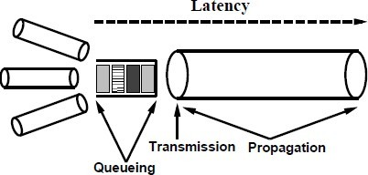

Propagation Time
- Propagation time measures the time required for a bit to travel from the source to the destination.
- The propagation time is calculated by dividing the distance by the propagation speed.
- The propagation speed of electromagnetic signals depends on the medium and on the frequency of the signal.

Transmission Time
- In data communications we don’t send just 1 bit, we send a message.
- The first bit may take a time equal to the propagation time to reach its destination.
- The last bit also may take the same amount of time.
- However, there is a time between the first bit leaving the sender and the last bit arriving at the receiver.
- The first bit leaves earlier and arrives earlier.
- The last bit leaves later and arrives later.
- The transmission time of a message depends on the size of the message and the bandwidth of the channel.

Queuing Time
- Queuing time is the time needed for each intermediate or end device to hold the message before it can be processed.
- The queuing time is not a fixed factor. It changes with the load imposed on the network. When there is heavy traffic on the network, the queuing time increases.
- An intermediate device, such as a router, queues the arrived messages and processes them one by one.
- If there are many messages, each message will have to wait.

Processing Delay
- Processing delay is the time that the nodes take to process the packet header.
- Processing delay is a key component in network delay.
- During processing of a packet, nodes may check for bit-level errors in the packet that occurred during transmission as well as determining where the packet's next destination is.

Bandwidth - Delay Product
- Bandwidth and delay are two performance metrics of a link.

The bandwidth-delay product defines the number of bits that can fill the link.
- This measurement is important if we need to send data in bursts and wait for the acknowledgment of each burst before sending the next one.
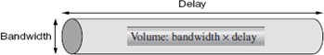

JITTER

- Another performance issue that is related to delay is jitter.
- Jitter is a problem that if different packets of data encounter different delays and the application using the data at the receiver site is time-sensitive (audio and video data, for example).
- If the delay for the first packet is 20 ms, for the second is 45 ms, and for the third is 40 ms, then the real-time application that uses the packets endures jitter.
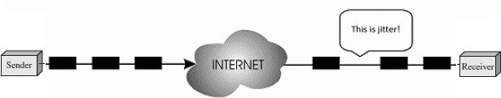

ROUND-TRIP TIME (RTT)

- RTT refers to how long it takes to send a message from one end of a network to the other and back, rather than the one-way latency. This is called as round-trip time (RTT) of the network.

SOLVED PROBLEMS – PERFORMANCE

Problem 1:
What is the propagation time if the distance between the two points is 12,000 km? Assume the propagation speed to be 2.4 × 108 m/s .

Solution :
Propagation time = (12000 * 1000) / (2.4 × 108) = 50 ms

Problem 2:
What are the propagation time and the transmission time for a 2.5-KB (kilobyte) message (an email) if the bandwidth of the network is 1 Gbps? Assume that the distance between the sender and the receiver is 12,000 km and that light travels at
2.4 * 108 m/s.

Solution:
Propagation time = (12000 * 1000) / (2.4 * 108 ) = 50 ms
Transmission time = (2500 * 8) / 109 = 0.02 ms

Problem 3:
What are the propagation time and the transmission time for a 5-MB (megabyte) message (an image) if the bandwidth of the network is 1 Mbps? Assume that the distance between the sender and the receiver is 12,000 km and that light travels at
2.4 * 108m/s.

Solution:
Propagation time = (12000 * 1000) / (2.4 * 108 ) = 50 ms
Transmission time = (5000000 * 8) / 106 = 40 s

  - Introduction to Sockets

  - Application Layer protocols

